Methodology Points

1. Tested with a model trained with only 15 images, tried to detect different items on one plate but nothing was detected except some of the plate area. This had only 1 iteration
2. Then I tried to use the model from 2nd year for pastizzi to detect the pastizzi in the plate of many food items, but all items were detected as pastizzi which was strange because the zalzett malti has different shape and colouring. A picture containing different, variety, arranged

   Description automatically generated
3. Then the model was trained on the same 15 images (made up if one food class per image) but this time, I did not include the plate region as part of the training to see if the detection would change. The main reason this was done was to check if a food class would be detected from a plate with multiple food classes because the model was trained with one food class per image)
4. Testing with the trained model in part 3 was done and it was concluded that we can train the model with one food class in the plate and then detect different classes.
5. It was decided to create a programm that rotates a single image by a certain degree and the mask for that image also gets rotated. We can then retrieve the BR for each augmented image.
6. Program was created. The program creates a json file for each rotated image with the rotated co-ordinates. Another programm was done to merge them all together.
7. With the help of the programs, the 15 images were turned into 414 images with a rotation of 15 degrees per image for 23 times. In each image only 1 food class was present to test if it would be possible to only train with 1 food class in each image, then detect multiple classes present in a single image. This unfortunately did not work out. No pixels/classes were detected after training the model with 414 single class training images and 5 multi class validation images. The masks generated from the rotations where checked and everything seemed fine. It was now opted to see what was wrong.
8. First we opted to choose only 1 class. Pastizzi and try to traing the model with pictures of pastizzi alone and test the model to see if it would detect it using an image which was also used in training. Then the same model was tested to detect an image which was not part of the training which only had a pastizz in it. The same thing was repeated with the zalzett.

Result of training only on the pastizzi images for 1 iteration (approx. 69 images)

This happens when we do not use the coco trained weights as a starting point when training our model.

Everytime we train a model we must make use of the pre trained weights since the number of images we are providing is small. The below is the same data set as the one above, but making use of the coco pre trained weights.

After this, a model with only zalzett malti was trained and it worked fine. Since this worked too, a model with both zalzett malti and pastizzi was used. This time, pictures which where not part of the training were used as validation. The results were promising. With images of 1 food item per image, detections where great. A test was made with an image of 5 similair foods and this was the result.

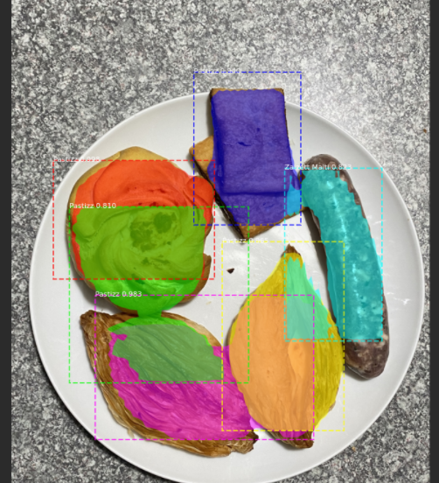

As one can see, the qassata and the imqaret where confused with pastizzi which is expected because ithe colours are similar, but this gives hope for when we test with 5 food items at the same time.